Space Diagonal

Definition
# Source: AI Source: Provided by: [Data Path: Persons Table -> ID Column: 1, Name_En Column: Motasem Essam] -> From: [ChatGPT] on [7/25/2026]
A space diagonal (also called a body diagonal or interior diagonal) of a cube is a line segment connecting two opposite vertices that do not belong to the same face.
It passes through the interior of the cube and intersects the cube's center.
A cube has four space diagonals, and all four have equal lengths.

Geometric Representation
# Source: AI Source: Provided by: [Data Path: Persons Table -> ID Column: 1, Name_En Column: Motasem Essam] -> From: [ChatGPT] on [7/25/2026]
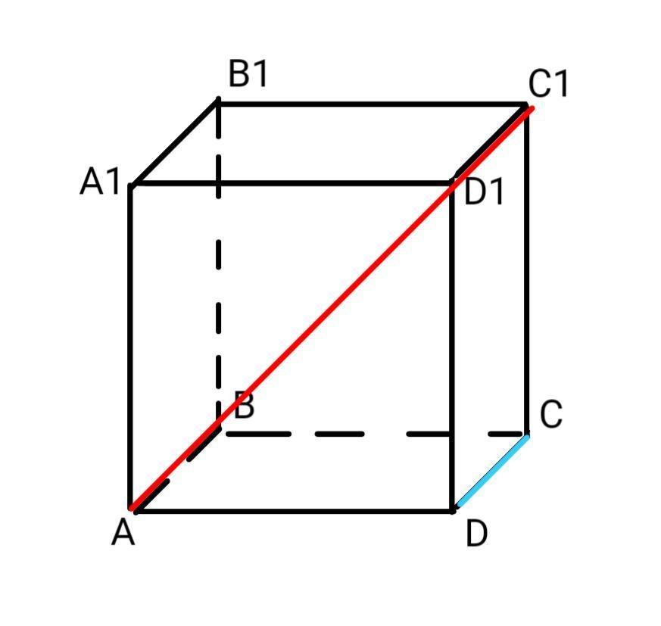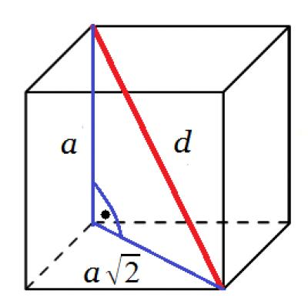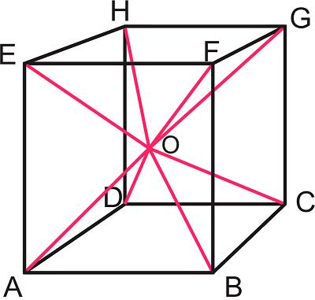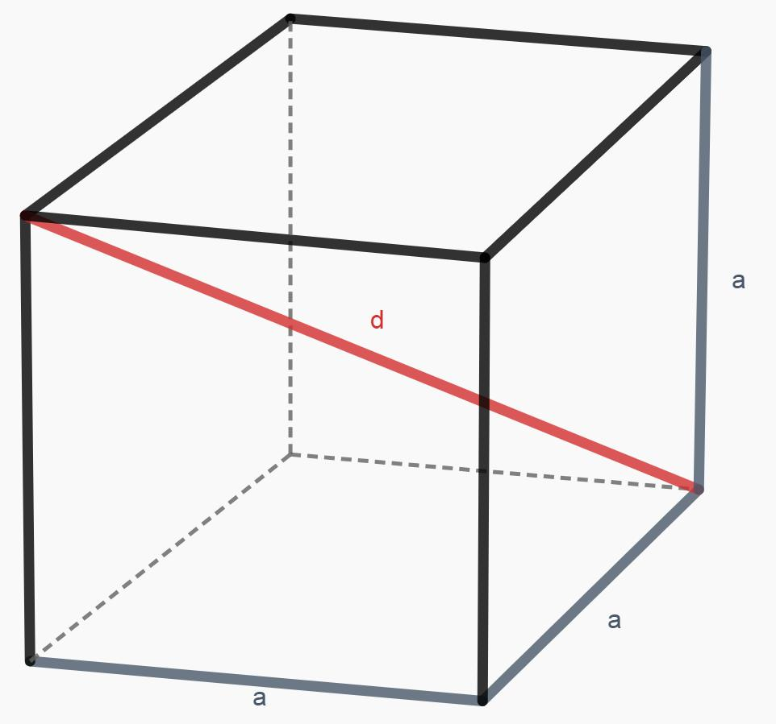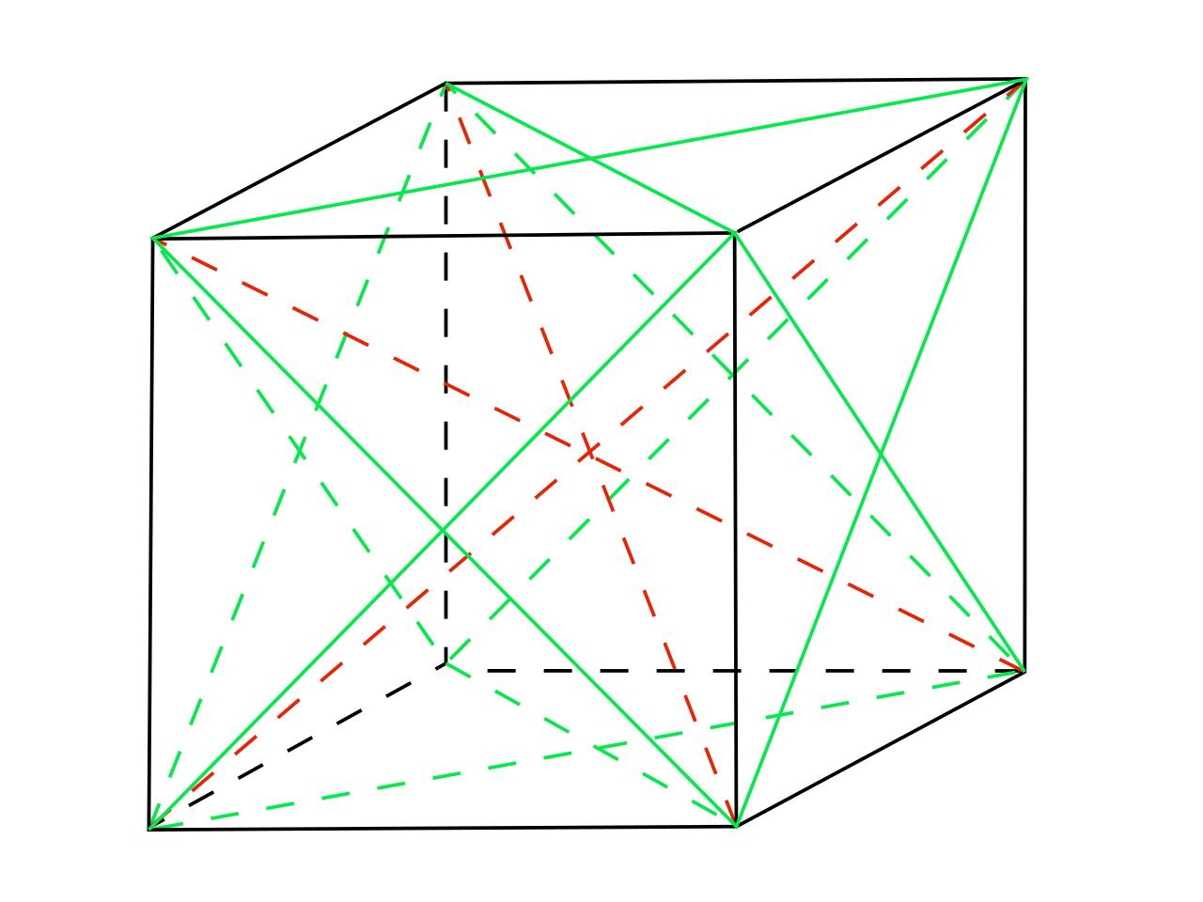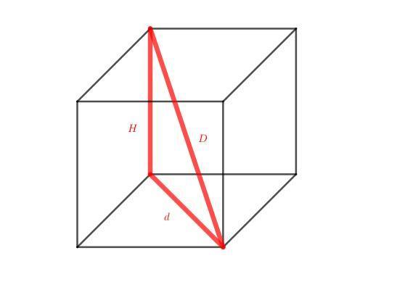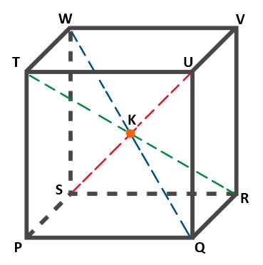

Geometric Structure
# Source: AI Source: Provided by: [Data Path: Persons Table -> ID Column: 1, Name_En Column: Motasem Essam] -> From: [ChatGPT] on [7/25/2026]
A space diagonal has the following characteristics:
- Location: Passes through the interior of the cube.
- Endpoints: Connects two opposite vertices of the cube.
- Position: Does not lie entirely on any single face.
- Intersection: Passes through the geometric center of the cube.
- Length: All four space diagonals have equal lengths.
- Direction: Connects opposite corners along the three-dimensional direction of the cube.

Number of Space Diagonals
# Source: AI Source: Provided by: [Data Path: Persons Table -> ID Column: 1, Name_En Column: Motasem Essam] -> From: [ChatGPT] on [7/25/2026]
A cube has eight vertices. Each vertex has exactly one opposite vertex.
Therefore:
$$N_{s}=\frac{8}{2}$$
$$\boxed{N_{s}=4}$$
A cube has 4 space diagonals.

Mathematical Properties
# Source: AI Source: Provided by: [Data Path: Persons Table -> ID Column: 1, Name_En Column: Motasem Essam] -> From: [ChatGPT] on [7/25/2026]
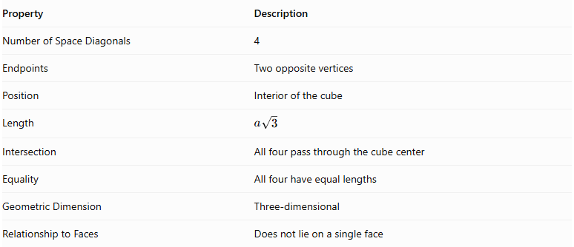
Property | Description
Number of Space Diagonals | 4
Endpoints | Two opposite vertices
Position | Interior of the cube
Length | $$a\sqrt{3}$$
Intersection | All four pass through the cube center
Equality | All four have equal lengths
Geometric Dimension | Three-dimensional
Relationship to Faces | Does not lie on a single face

Space Diagonal Formula
# Source: AI Source: Provided by: [Data Path: Persons Table -> ID Column: 1, Name_En Column: Motasem Essam] -> From: [ChatGPT] on [7/25/2026]
The length of a cube's space diagonal is calculated using the three-dimensional Pythagorean theorem.
Let:
- $a$ = Edge length of the cube.
- $d_{f}$ = Face diagonal length.
- $d_{s}$ = Space diagonal length.
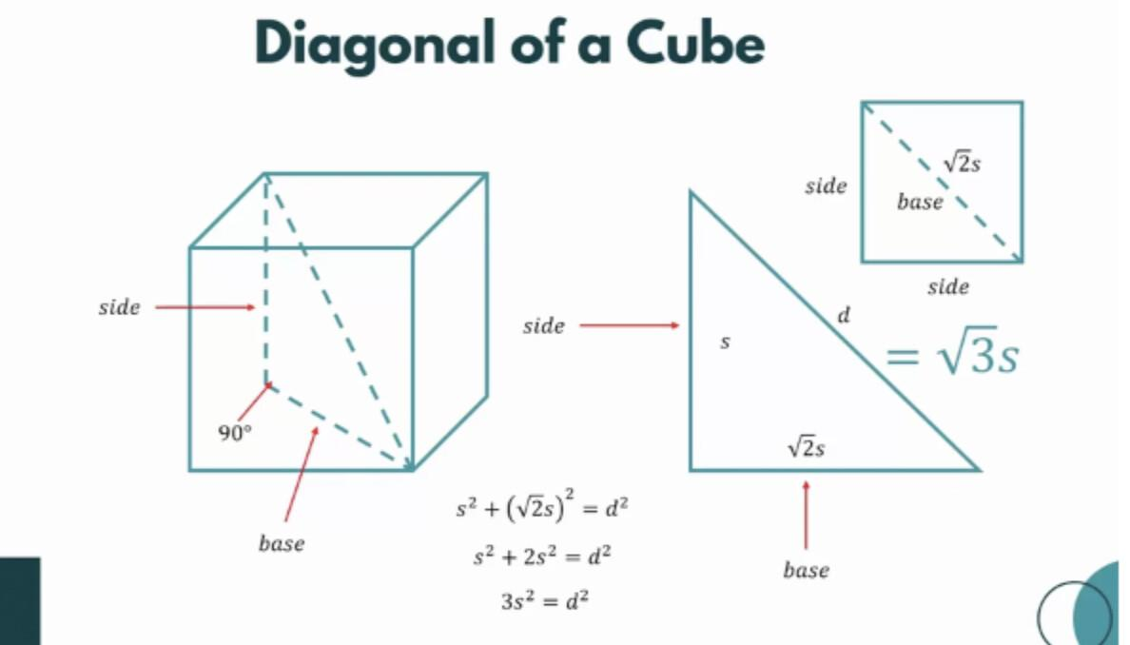

Derivation
# Source: AI Source: Provided by: [Data Path: Persons Table -> ID Column: 1, Name_En Column: Motasem Essam] -> From: [ChatGPT] on [7/25/2026]
First, calculate the face diagonal:
$$d_{f}^{2}=a^{2}+a^{2}$$
$$d_{f}^{2}=2a^{2}$$
Next, use the face diagonal and the third perpendicular edge to calculate the space diagonal:
$$d_{s}^{2}=d_{f}^{2}+a^{2}$$
Substitute:
$$d_{s}^{2}=2a^{2}+a^{2}$$
$$d_{s}^{2}=3a^{2}$$
Taking the square root:
$$\boxed{d_{s}=a\sqrt{3}}$$

Alternative Formula
# Source: AI Source: Provided by: [Data Path: Persons Table -> ID Column: 1, Name_En Column: Motasem Essam] -> From: [ChatGPT] on [7/25/2026]
If the space diagonal is known, the edge length can be calculated using:
$$\boxed{a=\frac{d_{s}}{\sqrt{3}}}$$

Approximate Value
# Source: AI Source: Provided by: [Data Path: Persons Table -> ID Column: 1, Name_En Column: Motasem Essam] -> From: [ChatGPT] on [7/25/2026]
$$\sqrt{3}≈1.7320508$$
Therefore:
$$d_{s}≈1.7321a$$
The space diagonal is approximately 1.7321 times the cube's edge length.

Geometric Relationships

Relationship with the Face Diagonal
# Source: AI Source: Provided by: [Data Path: Persons Table -> ID Column: 1, Name_En Column: Motasem Essam] -> From: [ChatGPT] on [7/25/2026]
The space diagonal and face diagonal form a right triangle with one cube edge.
$$\boxed{d_{s}^{2}=d_{f}^{2}+a^{2}}$$
Since:
$$d_{f}=a\sqrt{2}$$
Then:
$$d_{s}=a\sqrt{3}$$

Relationship with the Cube Center
# Source: AI Source: Provided by: [Data Path: Persons Table -> ID Column: 1, Name_En Column: Motasem Essam] -> From: [ChatGPT] on [7/25/2026]
All four space diagonals intersect at the geometric center of the cube.
The center divides each space diagonal into two equal segments.
$$\boxed{d_{c}=\frac{d_{s}}{2}}$$
Where $d_{c}$ is the distance from the cube center to any vertex.
Therefore:
$$\boxed{d_{c}=\frac{a\sqrt{3}}{2}}$$

Relationship with the Face Diagonal Length
# Source: AI Source: Provided by: [Data Path: Persons Table -> ID Column: 1, Name_En Column: Motasem Essam] -> From: [ChatGPT] on [7/25/2026]
The ratio between the space diagonal and the face diagonal is:
$$\frac{d_{s}}{d_{f}}=\frac{a\sqrt{3}}{a\sqrt{2}}$$
$$\boxed{\frac{d_{s}}{d_{f}}=\sqrt{\frac{3}{2}}}$$

Relationship with the Cube Volume
# Source: AI Source: Provided by: [Data Path: Persons Table -> ID Column: 1, Name_En Column: Motasem Essam] -> From: [ChatGPT] on [7/25/2026]
The volume of a cube is:
$$V=a^{3}$$
Since:
$$a=\frac{d_{s}}{\sqrt{3}}$$
Then:
$$\boxed{V=\frac{d_{s}^{3}}{3\sqrt{3}}}$$

Coordinate Geometry Representation
# Source: AI Source: Provided by: [Data Path: Persons Table -> ID Column: 1, Name_En Column: Motasem Essam] -> From: [ChatGPT] on [7/25/2026]
A cube centered at the origin can be represented using the following coordinates, where its edge length is $a$:
$$P_{1}=\left(-\frac{a}{2},-\frac{a}{2},-\frac{a}{2}\right)$$
$$P_{2}=\left(\frac{a}{2},\frac{a}{2},\frac{a}{2}\right)$$
These two points are opposite vertices.
Using the three-dimensional distance formula:
$$d_{s}=\sqrt{(x_{2}-x_{1})^{2}+(y_{2}-y_{1})^{2}+(z_{2}-z_{1})^{2}}$$
Substitution:
$$d_{s}=\sqrt{a^{2}+a^{2}+a^{2}}$$
$$\boxed{d_{s}=a\sqrt{3}}$$

Worked Examples
# Source: AI Source: Provided by: [Data Path: Persons Table -> ID Column: 1, Name_En Column: Motasem Essam] -> From: [ChatGPT] on [7/25/2026]
Example 1: Calculate the space diagonal of a cube with an edge length of 5 cm.
Given:
$$a=5\text{ cm}$$
Formula:
$$d_{s}=a\sqrt{3}$$
Substitution:
$$d_{s}=5\sqrt{3}$$
$$\boxed{d_{s}≈8.6603\text{ cm}}$$
Example 2: Calculate the edge length of a cube whose space diagonal is 12 cm.
Given:
$$d_{s}=12\text{ cm}$$
Formula:
$$a=\frac{d_{s}}{\sqrt{3}}$$
Substitution:
$$a=\frac{12}{\sqrt{3}}$$
$$\boxed{a=4\sqrt{3}≈6.9282\text{ cm}}$$

Comparison with Face Diagonal
# Source: AI Source: Provided by: [Data Path: Persons Table -> ID Column: 1, Name_En Column: Motasem Essam] -> From: [ChatGPT] on [7/25/2026]
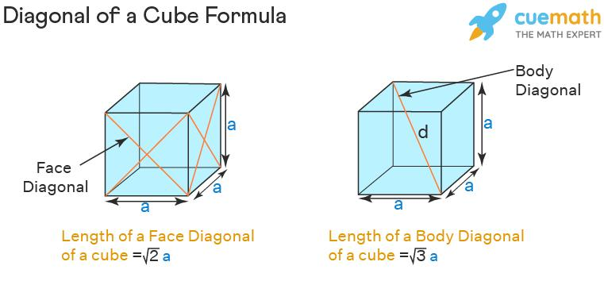
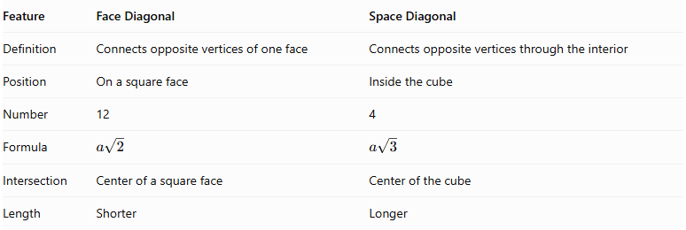
Feature | Face Diagonal | Space Diagonal
Definition | Connects opposite vertices of one face | Connects opposite vertices through the interior
Position | On a square face | Inside the cube
Number | 12 | 4
Formula | $$a\sqrt{2}$$ | $$a\sqrt{3}$$
Intersection | Center of a square face | Center of the cube
Length | Shorter | Longer

Main Classification
# Source: AI Source: Provided by: [Data Path: Persons Table -> ID Column: 1, Name_En Column: Motasem Essam] -> From: [ChatGPT] on [7/25/2026]
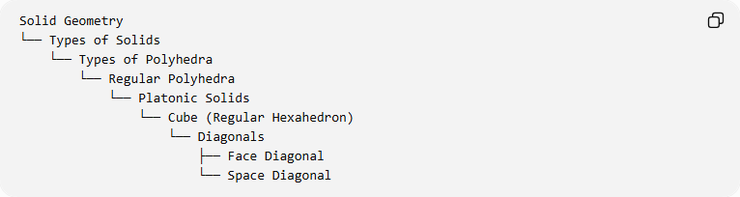
Solid Geometry
└── Types of Solids
└── Types of Polyhedra
└── Regular Polyhedra
└── Platonic Solids
└── Cube (Regular Hexahedron)
└── Diagonals
├── Face Diagonal
└── Space Diagonal

Key Points
# Source: AI Source: Provided by: [Data Path: Persons Table -> ID Column: 1, Name_En Column: Motasem Essam] -> From: [ChatGPT] on [7/25/2026]
- A space diagonal connects two opposite vertices of a cube.
- It passes through the interior and the geometric center of the cube.
- A cube has four space diagonals.
- All four space diagonals have equal lengths.
- Its formula is $d_{s}=a\sqrt{3}$.
- The cube center bisects every space diagonal.
- The space diagonal is longer than the face diagonal.

Conclusion
# Source: AI Source: Provided by: [Data Path: Persons Table -> ID Column: 1, Name_En Column: Motasem Essam] -> From: [ChatGPT] on [7/25/2026]
The Space Diagonal is a three-dimensional diagonal of a cube (Regular Hexahedron) connecting two opposite vertices through its interior. It has a length of $a\sqrt{3}$, and the cube contains four equal space diagonals that intersect at its geometric center.
References: Math Open Reference – Cube · Space Diagonal · Cube Diagonal Formula and Derivation

